FLORIDA GATEWAY COLLEGE

POLICY
_________________________________________________________________

TITLE: Drug-Free Campus NUMBER: 6Hx12:10-09
_________________________________________________________________

AUTHORITY: District Board of Trustees PAGE: 1
_________________________________________________________________

RESPONSIBILITY: Director, Human Resource Development
_________________________________________________________________

OTHER: State Board of Education Rule 6A-14.0261 DATE: See History Below
Public Law 100-690, SEC. 515
Drug-Free Campus
Florida Statutes 1001.64; 1001.65; 316.1936, 316.19, 316.1934,
562.11, 893.03, CFR Part 85, Section 85.615, 85.820
_________________________________________________________________

It is the policy of the District Board of Trustees that the unlawful manufacture, distribution, dispensation, possession or use of a controlled substance on the campus is prohibited.

_____________________
History: Adopted: 1/12/93; Effective: 1/12/93; Revised: 11/04/97
FLORIDA GATEWAY COLLEGE

PROCEDURE
_________________________________________________________________

TITLE: Drug-Free Campus PAGE: 1 of 5 _________________________________________________________________

AUTHORITY: District Board of Trustees DATE: See History
Below
_________________________________________________________________

RESPONSIBILITY: Director, Human Resources Development
_________________________________________________________________

NUMBER OF RELATED BOARD POLICY: 6Hx12:10-09
_________________________________________________________________

In keeping with its educational mission, Florida Gateway College will utilize primarily educational strategies as its major approach to addressing problems related to the abuse of alcohol and other drugs by any member of the College community (students, faculty and staff). However, any member of the College community who violates the drug and alcohol policy will be subject to prosecution and punishment by the civil authorities and to
disciplinary procedures of the College.

The intent of this procedure is to accomplish the following:

1. Prevent the abuse of alcohol and other drugs through a strong educational effort;

2. Encourage and facilitate the use of counseling services and rehabilitation programs by those members of the academic community who require their assistance in stopping the abuse of alcohol and other drugs; and

3. Discipline appropriately those members of the academic community who engage in substance abuse and related behaviors.

Educational Efforts to Prevent the Abuse of Alcohol and Other Drugs

In keeping with its primary mission of education, Florida Gateway College will conduct a strong educational program aimed

_____________________
History: Adopted: 1/12/93; Effective: 1/12/93; Revised: 11/04/97; 5/19/08
Procedure: 6Hx12:10-09
Continued
Page 2 of 5

at preventing the abuse of alcohol and other drugs. Educational efforts shall be directed toward all members of the academic community and will include information about the incompatibility of the abuse or sale of alcohol and other drugs with the goals of Florida Gateway College; the health hazards associated with the abuse of alcohol and other drugs; the incompatibility of alcohol and other drug abuse with the maximum achievement of educational, career, and other personal goals; and the potential legal consequences of involvement with alcohol and other drugs.

FGC will conduct a biennial review of its program to (a) determine its effectiveness and implement changes if they are needed; and (b) ensure that the sanctions below are consistently enforced.

Counseling and Rehabilitation Services to Prevent Alcohol and Other Drug Abuse

Those students, faculty, or staff who seek assistance for an alcohol or drug-related problem shall be provided with information about counseling and rehabilitation services available through the office of the Vice President for Student Services and other community resources. Those individuals who have failed to voluntarily avail themselves of services and/or who have failed to maintain satisfactory progress during the course of treatment and recovery will be subject to full disciplinary procedures according to College disciplinary policy. Those who voluntarily avail themselves of such services shall be assured that applicable professional standards of confidentiality will be observed.

Disciplinary Actions

Students, faculty members, administrators, and other employees are responsible, as citizens for knowing about and complying with the provisions of Florida law that make it a crime to possess, sell, deliver, or manufacture those drugs designated collectively as "controlled substances" in Chapter 893, Sections 035, .0355, and .0356 of the Florida Statutes. The following minimum penalties shall be imposed for the particular offenses described.

College Regulations Governing Illegal Drugs:
1. Trafficking in Illegal Drugs
a. For the illegal manufacture, sale or deliver, or possession with intent to manufacture, sell or deliver, of any controlled substance identified in Schedules I and II of Chapter 893.03 of the Florida Statutes, (including, but not limited to, heroin, cannabis, mescaline, lysergic acid diethylamide (LSD), opium, cocaine, amphetamine, MDMA (ectasy), methaqualone), any student shall be expelled and any faculty member, administrator, or other employee shall be discharged.

Procedure: 6Hx12:10-09
Continued
Page 3 of 5

b. For a first offense involving the illegal manufacture, sale or delivery, or possession with intent to manufacture, sell or deliver, of any controlled substance identified in Schedules III through V of Chapter 893.03 of the Florida Statutes (including, but not limited to steroids, diazepam, phenobarbital), the minimum penalty shall be suspension from enrollment or employment. For a second offense, any student shall be expelled and any faculty member, administrator, or non-probationary employee shall be discharged.

2. Illegal Possession of Drugs

a. For a first offense involving the illegal possession of any controlled substance identified in Schedules I or II of Chapter 893.03 of the Florida Statutes, the minimum penalty shall be suspension.

b. For a first offense involving the illegal possession of any controlled substance identified in Schedules III through V of Chapter 893.03 of the Florida Statutes, the minimum penalty shall be probation for a period to be determined on a case-by-case basis. A person on probation must agree to participate in a drug education and counseling program, consent to regular drug testing, and accept such other conditions and restrictions as the appropriate College official deems appropriate.

c. Refusal or failure to abide by the terms of probation or second or other subsequent offenses involving the illegal possession of controlled substances, progressively more severe penalties shall be imposed, including expulsion of students and discharge of faculty members, administrators or employees. These penalties will be in accordance with College disciplinary procedures and/or the collective bargaining agreement.

3. Possession, Sale, or Consumption of Alcoholic Beverages

Procedure: 6Hx12:10-09
Continued
Page 4 of 5

a. Possession, sale, or consumption of alcoholic beverages on campus, or at off-campus College sponsored activities is prohibited unless specifically authorized. Alcoholic beverages include, but are not limited to beer, wine, distilled spirits, wine coolers, and liqueurs. (Request form to Allow Alcoholic Beverages on College Property follows last page of procedure.)

b. State laws are outlined as follows:

(1) Drinking Age
-The legal drinking age in Florida is 21.
-Selling, giving or serving alcoholic beverages to persons under 21 is unlawful.
-In Florida, this law extends to possession of alcoholic beverages by anyone under 21.
-It is unlawful for any person to misrepresent to misstate his or her age. This includes the manufacture of use of false identification. Use of altered identification for the purpose of procuring alcoholic beverages is a felony.

(2) Open Container Law
-It is unlawful for any person to consume or possess open containers of alcoholic beverages while in municipal parks, playgrounds, sidewalks, or streets.

(3) D.U.I. (Driving while under the influence of alcohol or other drugs.)
-A mandatory suspension of license for 90 days for the first conviction.
-Fines of up to $500 for the first offense.
-A minimum of 50 hours of community service.
-Imprisonment of not more than six (6) months.

c. In addition to the legal requirements and penalties above, students found to be in violation of this College policy will be subject to penalties under the Student Code of Conduct.

Faculty and staff in violation of this College policy will be subject to disciplinary actions as outlined in College disciplinary procedures and/or the collective bargaining agreement. Mandatory participation in rehabilitation and educational programs will be regulated by State and Federal statutes.

Procedure 6Hx12:10-09
(Continued)
Page 5 of 5

Conditions for Immediate Suspension

When a student, faculty member, administrator, or other employee has been charged by the College with a violation of policies concerning alcohol and other drugs, he or she may be suspended from enrollment or employment before initiation or completion of regular disciplinary proceedings, if assuming the truth of the charges, the responsible authority concludes that the person's continued presence within the College community would constitute a clear and immediate danger to the health or welfare of other members of the College community.

An immediate suspension and subsequent hearings will be in accordance with College disciplinary procedures.

Civil Conviction for Drug and Alcohol Offenses

If employees of Florida Gateway College in performance of College duties within the scope of their employment are convicted of an offense related to drugs, they will be subject to the same penalties as the offense would warrant if the offense were committed on College property or at a College sponsored event. The term "conviction" means a finding of guilt (including a plea of nolo contendere) or imposition of sentence, or both, by any judicial body charged with the responsibility to determine violations of the Federal or State criminal drug statutes.

The individual involved is required to notify the College of the conviction or arrest within five (5) working days following said conviction or arrest.

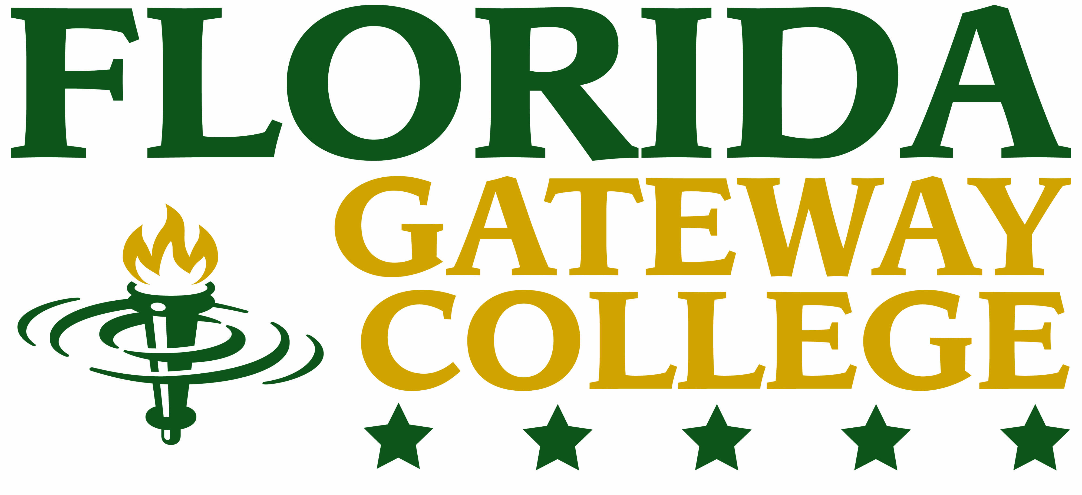

REQUEST TO ALLOW ALCOHOLIC BEVERAGES ON COLLEGE PROPERTY
NOTE: ONLY BEER AND/OR WINE ARE ALLOWED

Organization:
Contact Person: |  |  | Phone:
Mailing Address:
Name of Event: |  |  | Date of Event:
Complete Description of Event:
Circumstances Relating to the Sale and/or Consumption of Alcoholic Beverages:

Conditions and Agreements

- This completed and signed request form must be submitted to the College President, or designee, 14 days prior to the event, along with copies of appropriate liquor licenses/permits. It is the responsibility of the requestor to obtain all required licenses/permits related to the sale of alcoholic beverages (only beer and wine allowed) in accordance with Florida Statutes. The sponsoring organization will adhere to all Florida Statutes, local regulations and ordinances, and to the Florida Division of Alcoholic Beverages and Tobacco rules and regulations governing the use, sale, and consumption of alcoholic beverages.

- External organizations and caterers must submit a Certificate of insurance listing the Florida Gateway College District Board of Trustees as an “additional insured” to the College President, or designee, no less than 14 days prior to the event. Such insurance shall be in the amount of no less than one million dollars, single limit coverage. In addition, the organization shall defend, indemnify and hold the College harmless from and against liability, claims, losses, both bodily injury and property, and expenses which arise out of or from the organizations negligent actions or non-actions.

- Florida Gateway College reserves the right to require a law enforcement officer to be present, with the external organization bearing all costs, at any event held on College property should the President, or designee, deem this requirement to be in the best interests of the College.

- In all cases, Florida Gateway College reserves the right to refuse to allow the sale and/or consumption of alcoholic beverages on College property, without obligation to provide reason or cause.

- Approval of this request is not final until an approved copy of this request form with all signatures indicated below is returned to the requestor.

I have read and understand these Conditions and agree that the organization I represent (The Organization) will comply with these provisions. I hereby certify that I am authorized to execute this document on behalf of The Organization and bind The Organization to this agreement as well as any other collateral documents. In the event that The Organization is not a legal entity, I agree that the obligations of The Organization contained within this agreement and any collateral documents shall be my personal responsibility.

Signature of Requestor: |  |  |  | Date:
Printed Name: |  | Title:
Organization:
Risk Management Coordinator: |  |  |  | Date:
College President: |  |  |  | Date:

