FLORIDA GATEWAY COLLEGE

POLICY

TITLE: Instructional Work Schedule NUMBER: 6Hx12:4-05

AUTHORITY: District Board of Trustees PAGE: 1

RESPONSIBILITY: Vice President, Academic Affairs DATE: See History Below

OTHER: Florida Statutes: 1001.64, 1001.65, 1012.82
College Policies: 6Hx12:7-14, 6Hx12:7-10, 6Hx12:6-13, 6Hx12:3-03

It is the policy of the District Board of Trustees to determine the instructional work schedule in accordance with applicable State Board Rules and Florida Statutes.

History: Adopted: 1/11/83; Effective: 1/11/83; Revised: 7/14/87; 4/12/88; 02/14/95; 6/11/96; 03/11/03; 7/21/21
FLORIDA GATEWAY COLLEGE

PROCEDURE

TITLE: Instructional Work Schedule PAGE: 1 of 7

AUTHORITY: District Board of Trustees DATE: See History Below

RESPONSIBILITY: Vice President, Academic Affairs

NUMBER OF RELATED BOARD POLICY 6HX12:4-05

FULL-TIME FACULTY

- ALL COLLEGE CREDIT FULL-TIME FACULTY (except Nursing and Health Sciences)

For Full-time faculty who are assigned college credit classes in Associate of Arts, Associate of Science, and college credit certificate programs except Nursing and Health Sciences programs. These faculty members occupy a Board approved, budgeted position and are on a normal forty (40) hours per week contract. For the regular fall/spring terms, these faculty members have a choice of teaching in one of the following two categories: A – twenty-five (25) hours per week on campus or B – thirty-three (33) hours per week on campus. Any release time for all faculty and/or instructional coordinators must be approved by the President.

Category A (25 hours on campus) – Eighteen (18) contact hours in classes (six classes or equivalent) in adherence to Figure 1, seven (7) hours of on-campus office hours, with 15 hours scheduled for professional responsibility, with a minimum of 164 duty days as outlined in the school calendar. Fifteen (15) additional hours of professional responsibility are scheduled either on or off campus to make up the 40-hour work week.

Category B (33 hours on campus) – Fifteen (15) contact hours in classes (five classes or equivalent) in adherence to Figure 1, seven (7) hours of on-campus office hours, three (3) virtual office hours, eight (8) hours scheduled on campus for student support and other work, and seven (7) hours for professional responsibility, with a minimum of 164 duty days as outlined in the school calendar. Seven (7) additional hours of professional responsibility are scheduled either on or off campus to make up the 40-hour work week.
Virtual Office Hours for Category B
The virtual office hours scheduled must meet the following requirements:
- Virtual time must be designated on the instructor door scheduled submitted each term.
- Virtual time must be designated in each course syllabus and on Canvas.
- Virtual time must utilize the Microsoft Teams video conferencing platform. Faculty must be present in the virtual conference “room” during all virtual office hours.

Procedure 6Hx12:4-05
(Continued)
Page 2 of 7

- Link(s) to the virtual conference room must be included in course syllabi, the instructor door schedule, and on Canvas.
- Acceptable activities for virtual office hours are planned discussions, question and answer sessions, and other instructional activities.
- Faculty who does not wish to conduct the office hours virtually may hold all office hours in their campus office. 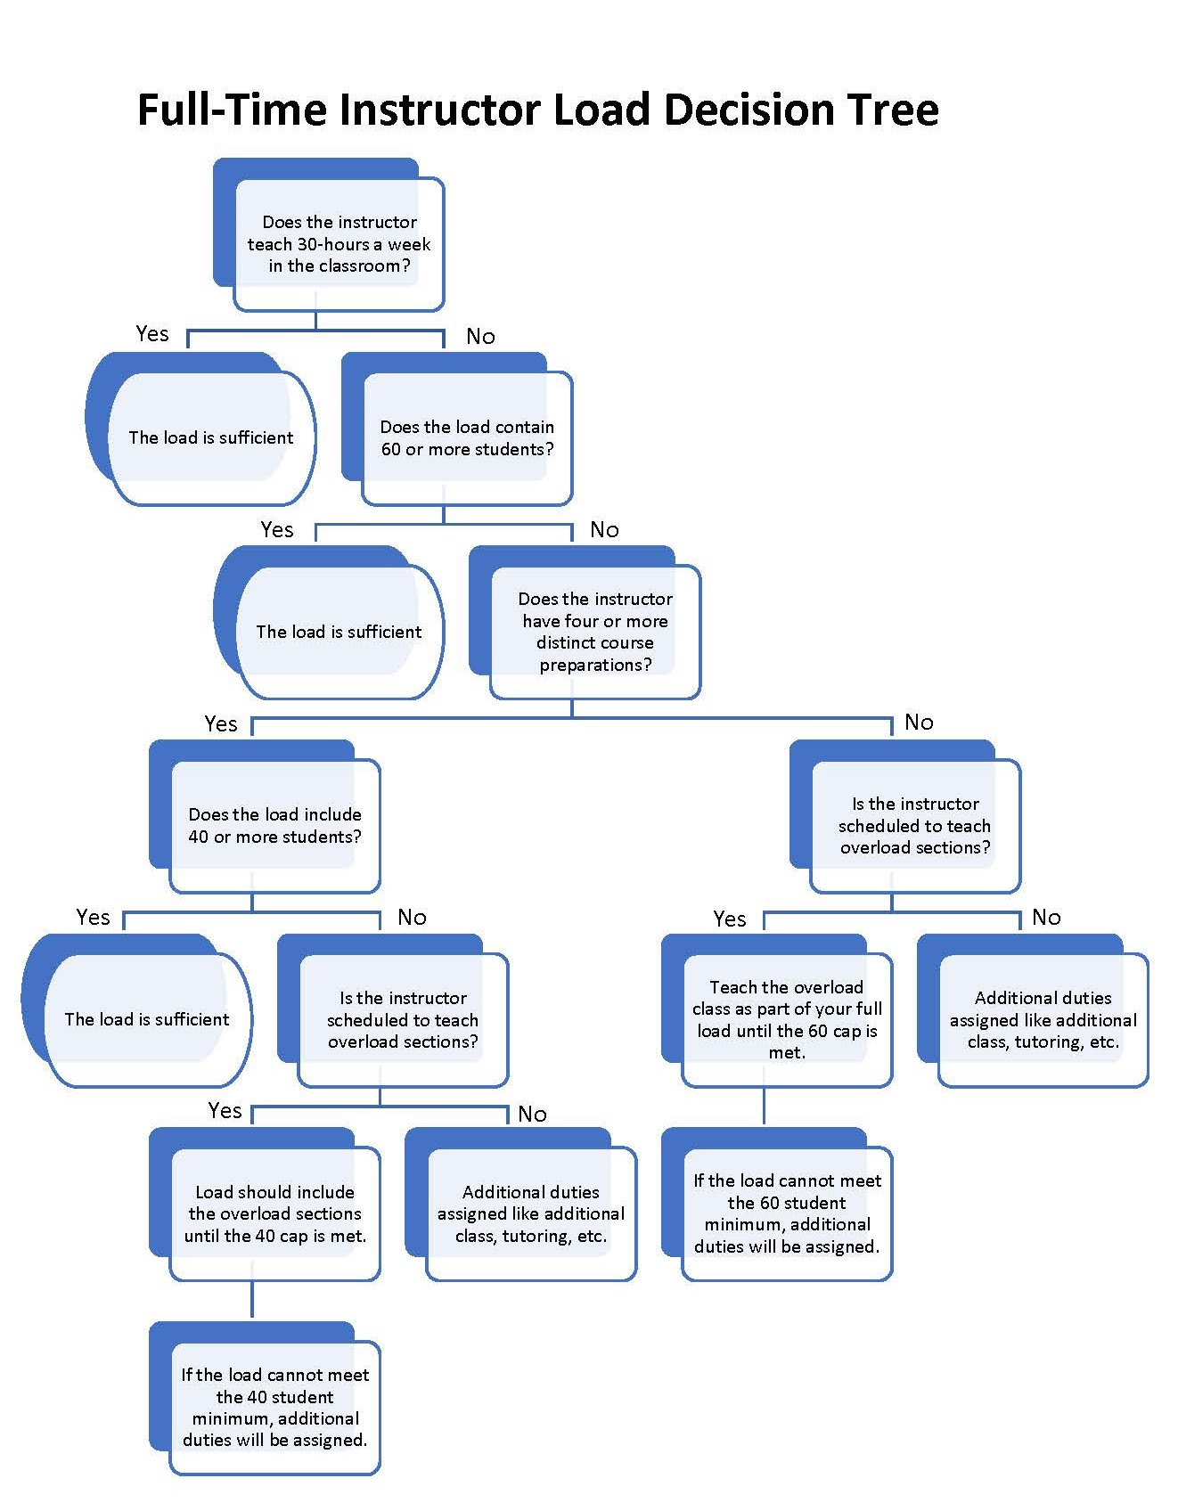

Figure 1

Procedure 6Hx12:4-05
(Continued)
Page 3 of 7

The faculty members in these two categories receive all benefits accorded other full-time employees except for annual leave and paid holidays. Any overload classes taught are considered extra time and not included in these basic times, i.e., each three (3) contact hour class would also add thirty (30) minutes scheduled office hours per a three (3) hour class above the A & B categories.

Unless specifically exempted by the appropriate Director, Executive Director, Associate Dean, Dean, Vice President, or President, all full-time faculty are to be available for:

- Required class time
- Required clinical (health related courses)
- Office hours
- Faculty meetings as called
- Committee meetings
- Attendance at college-related functions as required
- Academic Advising
- Student Recruitment

Teaching Load - Faculty will be assigned classes by the division Dean, Associate Dean Directors/Executive Directors, or Coordinators. The faculty’s regular load will consist of courses and activities for which the faculty is deemed qualified. Normal teaching loads are as follows:

During the fall and spring terms a full load is defined as teaching either 18 or 15 credit hours in adherence to Figure 1 depending on the schedule a faculty member selects, Category A (25 hours on campus) or Category B (33 hours on campus) as detailed on page 1 of procedure.

During summer terms, full-time faculty may teach in adjunct status per the salary schedule, or choose to accept a rate of pay that is associated with more office hours and on campus time, but not to exceed 18-credit hours for the summer. For faculty choosing the daily rate calculation, the pay will be determined using the following chart:

If enrollment is: | Take daily rate & multiply by
 | 1 CR HR | 2 CR HR | 3 CR HR | 4 CR HR | 5 CR HR
24+ students | 3.333 | 6.667 | 10 | 13.333 | 16.667
17 – 23 | 2.9 | 5.8 | 8.7 | 11.6 | 14.5
11 – 16 | 2.467 | 4.933 | 7.4 | 9.867 | 12.333
7 – 10 (if approved) | 2.167 | 4.333 | 6.5 | 8.667 | 10.833
4 – 6 (if approved) | 1.667 | 3.333 | 5.0 | 6.667 | 8.333
1 – 3 (if approved) | 1.3 | 2.6 | 3.9 | 5.2 | 5.2
Note: The maximum number of credits that can be paid according to this chart is 18 total credit hours during the summer.

Procedure 6Hx12:4-05
(Continued)
Page 4 of 7

Summer Office Hours – Office hours per week are determined by the number of courses (on-line or traditional) taught per term. Outside of hours devoted to instruction, office hours are required for meetings on campus or for support of students. Below are the required number of class time hours and office hours that must be scheduled each week for the 4-week, 6-week, and 12-week summer terms.

Hours required per course according to term
 | # of hours per week for class time | # of office hours per week | # of office hours if at adjunct rate (over 18 credits) | Add the following time for any credits over 3 per course
 |  |  |  | Class time | Office hour
4-week term  (A4, B4 or C4) | 12 | 3.75 | 2.25 | 3 | 1.5
6-week term  (A6 or B6) | 8 | 2.5 | 1.5 | 2 | 1
12-week term  (A12) | 4 | 1.25 | 0.75 | 0.75 | 0.25

Office hours must be fulfilled on campus if faculty are accepting the daily rate pay method. Faculty choosing the adjunct rate of pay complete office hours according to adjunct guidelines listed in the table above. In cases where a faculty member’s load exceeds the 40-hour work week, exceptions may be made by the appropriate administrator with final approval by the appropriate Vice President.

Extra Contact Hour pay for Summer - As a definition for the number of hours a week one contact hour should equal is:

1 contact hour = 1.34 hours per week for a 12-week term
2.67 hours per week for a 6-week term
4.0 hours per week for a 4-week term

Faculty pay for summer term lab course contact hours overload will be calculated using the following formula:

If enrollment is: | # of extra contact hours over normal load | Multiply by
24+ student | X hours over | 400
17-23 | X hours over | 348
11-16 | X hours over | 296
7-10 | X hours over | 260
4-6 | X hours over | 200
1-3 | X hours over | 156

Procedure 6Hx12:4-05
(Continued)
Page 5 of 7

- Full-time faculty assigned College Credit classes in Nursing and Health Sciences Associate of Science programs:

During fall and spring terms, course load is 15-credit hours (translated to 225 contact hours), which represents a combination of credit lecture courses and time spent in a clinical setting. Classroom contact hours and required office hours are to be completed on campus. For faculty falling short of the 15-credit hours (225 contact hour requirement) in a given term, their load must be increased in the following term to make up the difference. Additional hours of professional responsibility are scheduled either on or off campus to make up the 40-hour work week.

During summer terms A and B, course load is six (6) credit hours per term, which translates to 90 contact hours. Classroom contact hours and required office hours are to be completed on campus. In the summer, faculty are required to be on campus or in a clinical setting for a total of 33 hours per week, which is part of the total required hours as detailed on page 1. Any shortfall in overall credit hours for the academic year must be rectified in the summer.

- Faculty Load for Instrumental & Voice Lessons Taught by Full-time faculty

Applied music lessons will be counted toward faculty load at the ration of five (5) half-hour lessons (or any combination equaling 2.5 hours of instruction) to one (1) 3-semester hour class.

- Full-time faculty assigned vocational credit courses in Certificate programs:

A full-time faculty member’s load is the equivalent of 30 student contact hours. These contact hours will be scheduled within the 33 hours the faculty are required to be on campus and office hours will be adjusted accordingly to accommodate the scheduled classroom contact hours. Seven (7) additional hours of professional responsibility are scheduled either on or off campus to make up the 40-hour work week.

- Full-Time Faculty in Baccalaureate Programs

Full-time faculty assigned college credit courses in baccalaureate programs occupy a Board approved, budgeted position and are on a normal forty (40) hours per week contract. For the regular fall/spring terms, these faculty members have a choice of teaching in one of the following two categories: A – twenty-five (25) hours per week on campus or B – thirty-three (33) hours per week on campus.

Category A (25 hours on campus) – Fifteen (15) credit hours in classes (five classes or equivalent) in adherence to Figure 1, seven (7) hours of on-campus office hours, with 18 hours scheduled for professional responsibility, with a minimum of 164 duty days as outlined in the school calendar. Fifteen (15) additional hours of professional responsibility are scheduled either on or off campus to make up the 40-hour work week.

Procedure 6Hx12:4-05
(Continued)
Page 6 of 7

Category B (33 hours on campus) – Twelve (12) credit hours in classes (four classes or equivalent) in adherence to Figure 1, seven (7) hours of on-campus office hours, three (3) virtual office hours, eight (8) hours scheduled on campus for student support and other work, and seven (7) hours for professional responsibility, with a minimum of 164 duty days as outlined in the school calendar. Seven (7) additional hours of professional responsibility are scheduled either on or off campus to make up the 40-hour work week.

Virtual Office Hours for Category B
The virtual office hours scheduled must meet the following requirements:
- Virtual time must be designated on the instructor door scheduled submitted each term.
- Virtual time must be designated in each course syllabus and on Canvas.
- Virtual time must utilize the Microsoft Teams video conferencing platform. Faculty must be present in the virtual conference “room” during all virtual office hours.
- Link(s) to the virtual conference room must be included in course syllabi, the instructor door schedule, and on Canvas.
- Acceptable activities for virtual office hours are planned discussions, question and answer sessions, and other instructional activities.
- Faculty who does not wish to conduct the office hours virtually may hold all office hours in their campus office.

Any overload classes taught are considered extra time and not included in these basic times, i.e., each three (3) credit hour class would also add thirty (30) minutes scheduled office hours per a three (3) hour class above the A & B categories.

Unless specifically exempted by the appropriate Dean, Director, Executive Director, Vice President, or President, all full-time faculty are to be available for:
  - Required class time
  - Required clinical (health related courses)
  - Office hours
  - Faculty meetings as called
  - Committee meetings
  - Attendance at college-related functions as required
  - Academic Advising
  - Student Recruitment

During fall and spring terms a full load is defined as teaching 12-credit hours. To meet BOT faculty contractual requirements faculty will have 2 credits for scholarship and one credit for practice in fall and spring to meet scholarship (research) and practice requirements of those teaching at this level.

Overload pay - The Vice President of Academic Affairs, upon recommendation of a Dean, Associate Dean, Director/Executive Director, may recommend overload pay in allowable circumstances. Approved overload pay will be computed per the salary schedule.

Procedure 6Hx12:4-05
(Continued)
Page 7 of 7

- All Faculty Coordinators receiving a stipend

For the Fall and Spring semesters - All faculty coordinators are required to designate 7 hours per week of campus hours for coordinating duties on their schedule. These hours must be outside of the required contact and office hours.

For the Summer semester - All faculty coordinators are required to schedule 8 hours each week on campus for coordinating duties during the summer C term. Any deviation must be approved prior to the term by the Dean or Executive Director of the division.

PART-TIME FACULTY

PART-TIME FACULTY – Part-time faculty is defined as an employee who works less than an eight-hour day or 40-hour week.

Part-time faculty are required to meet all classes as scheduled. Additionally, they must be available to students 30 minutes per week per 3-credit hour course or equivalent. Part-time faculty teaching online courses may complete office hours virtually, while faculty teaching traditional campus courses should maintain campus office hours.

DOCUMENTATION FOR ALL FACULTY

REQUIRED DOCUMENTATION for ALL FACULTY - Faculty shall be required to submit an Instructor's Class Schedule form and a Faculty Load Report form to his or her Director/Executive Director/Dean.

The Dean, Director/Executive Director of each division shall be responsible for keeping records of class loads, including numbers of students in each class and of assignments made to faculty in lieu of classroom assignments.

One copy of the faculty’s (full-time and part-time) work schedule shall be filed with the appropriate Dean, Director/Executive Director and one shall be posted in clear view at the faculty’s office. Each schedule should fully account for each faculty’s work hours during each term. A copy of the Instructor's (full-time and part-time) Faculty Load Report form shall be filed with Human Resources. When requesting overload pay, a Faculty Load Report must be submitted with the faculty’s contract.

History: Adopted: 2/14/95; Effective: 2/14/95; Revised: 6/11/96, 01/09/01, 03/11/03; 04/02/03, 02/2/09, 02/09/10, 05/03/10; 05/02/11; 10/26/2012; 8/18/15; 9/15/15; 05/03/16; 04/02/19; 1/27/21; 7/21/21; 5/12/22; 5/17/23

